# A Project Report on

# HR Payroll Automation

## Submitted to Smart Bridge

By:

**Arun Valliappan Valliappan 19R11A0541**

**Kanithi Hemanth 19R11A05H3**

**Sama Likhitha Reddy 19R11A04P0**

**Vudem Shravani Reddy 19R11A04P9**



## Under the guidance of

### Mr. Hemant Kumar Gahlot

### Lead – RPA/Intelligent Automation at SmartBridge Educational Services Pvt. Ltd

Table of Contents:

|  |  |
| --- | --- |
| **Title** | **Page Number** |
| 1. Introduction | 3 |
| 1. Flow chart  * Stage configurations | 4 |
| 1. Input & Output | 12 |
| 1. Pros and Cons | 13 |
| 1. Applications | 14 |
| 1. Conclusion | 15 |
| 1. Future Scope | 16 |

**Introduction:**

Payroll and salary administration are necessary tasks within every HR department, even if there is a separate payroll team. In recent years, both have been made significantly easier with new technology, but there is still the risk of human error, and it can take hours of work to complete payday obligations. And, as everyone in HR has experienced at one point in their careers, a simple error in payroll can easily lead to disgruntled employees. By using Digital Workers, the payroll process can be virtually pain-free. With their ability to work easily across multiple systems and in tandem with your team, Digital Workers can complete the traditionally manual salary and payroll administration process effectively and accurately, ensuring your people are paid the correct amount and speeding up the monthly process that many teams dread. According to a study which examines the perception of employees regarding HR process automation in terms of both individual as well as organizational level, implementing such automated tools for HR processes will create a friction between the current and newly formulated practices. Whether HR automation can deliver the quality and satisfaction that it promises? This remains a critical question to answer in today’s fast moving technology dependent world.

* Payroll is a list of employees who get paid by the company. Payroll also refers to the total amount of money employer pays to the employees.
* **Robotic Process Automation** (RPA) is a type of automation technology currently transforming the way businesses operate.
* Excel automation streamlines your use of the application by automatically performing tasks.

Here in this project we had made use of RPA to efficiently process the payroll of each of the employees of a company.

The HR Payroll Automation permits you to:

* Manage Employee Information Efficiently.
* Define the emoluments, deductions, leave etc.
* Generate and Manage the Payroll Processes according to the Salary Structure assigned to the employee.

**Flow Chart:**

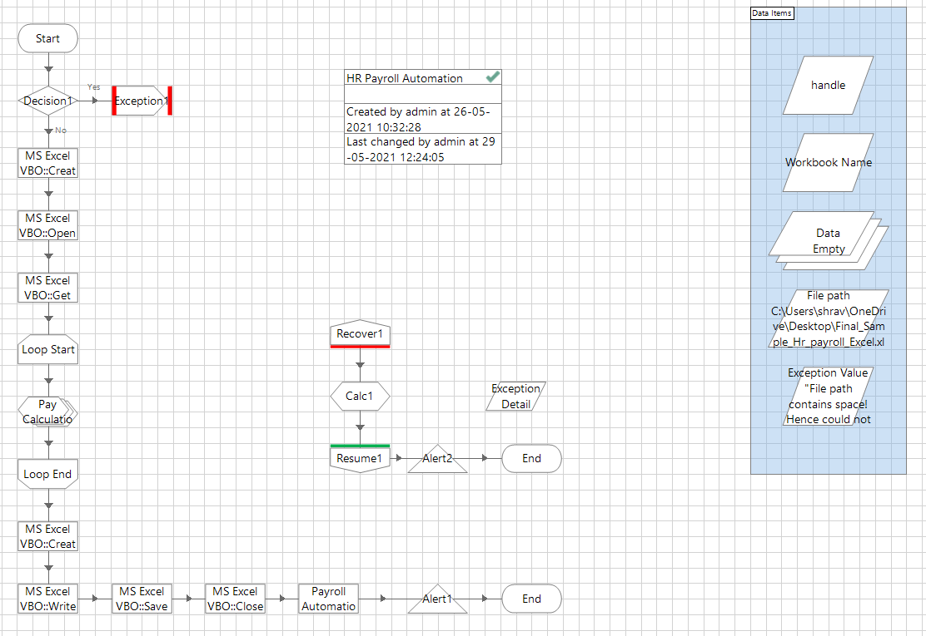

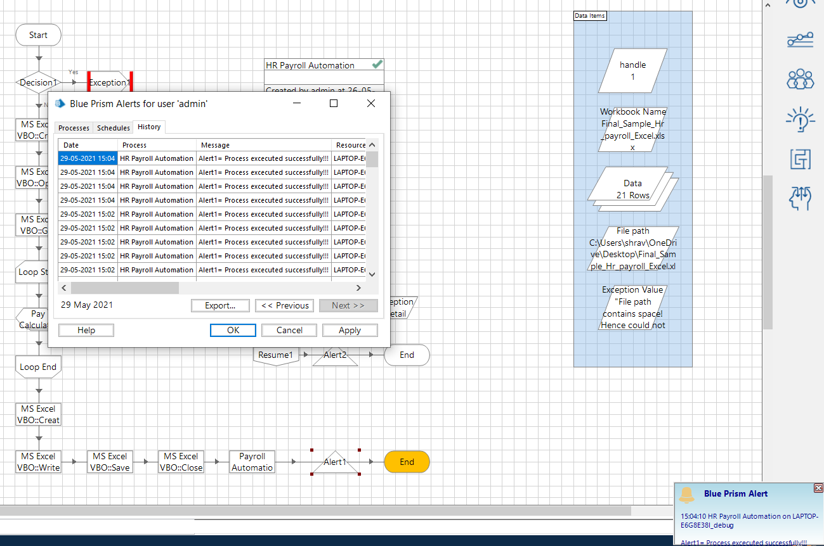

* Stage configurations:

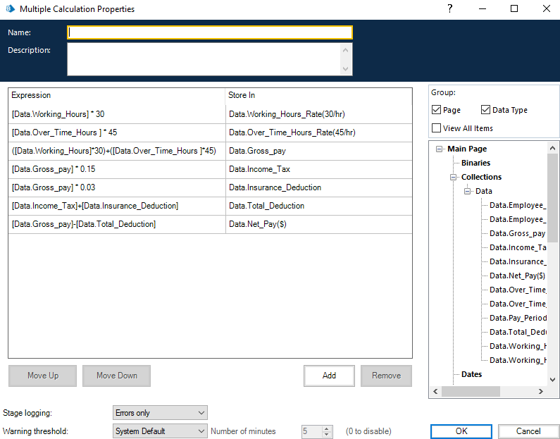

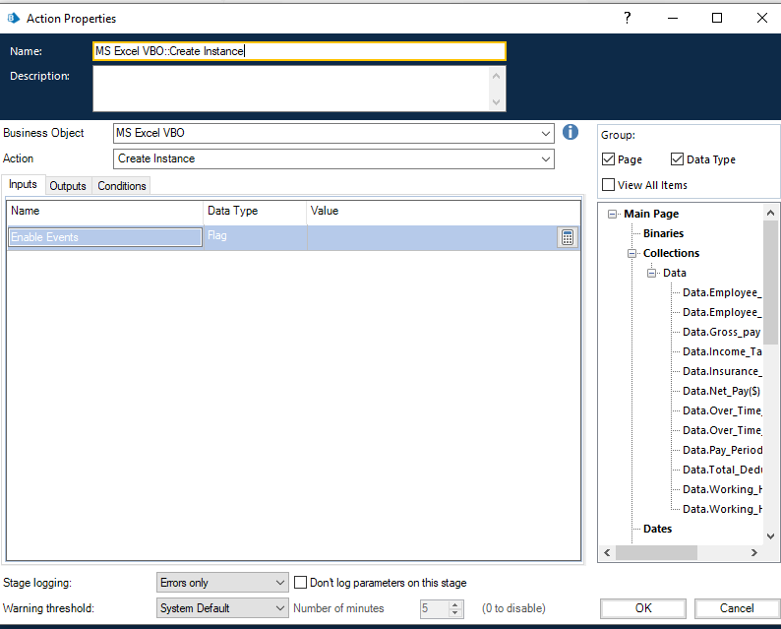

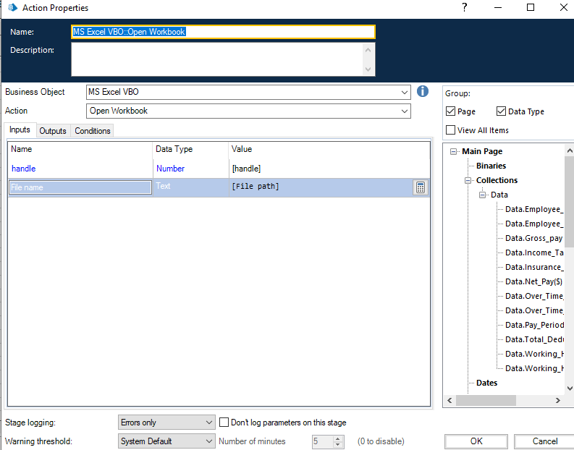

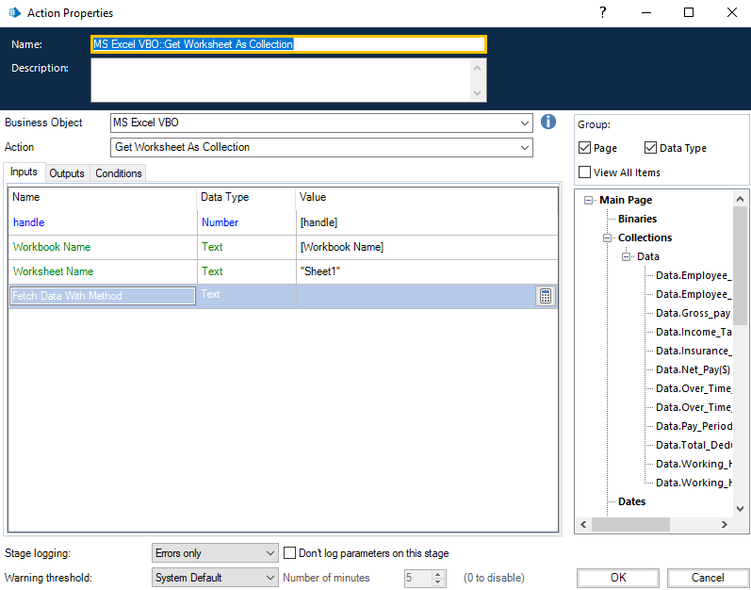

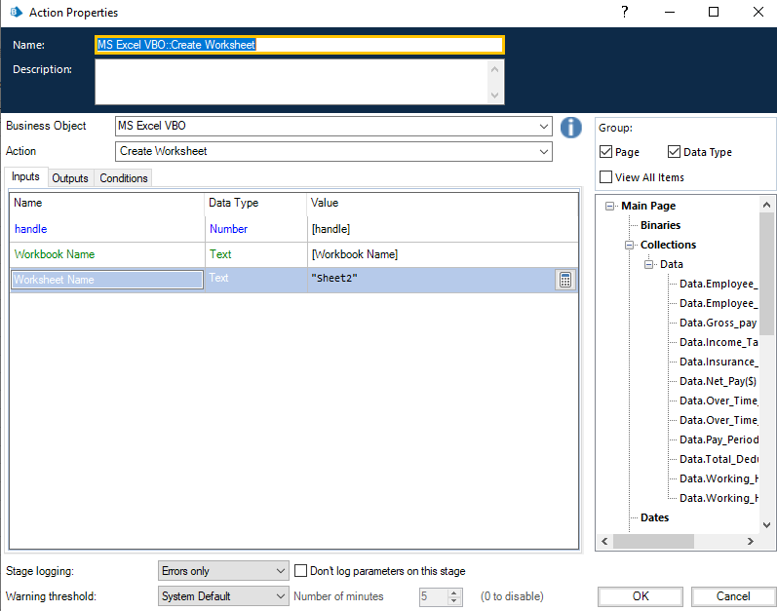

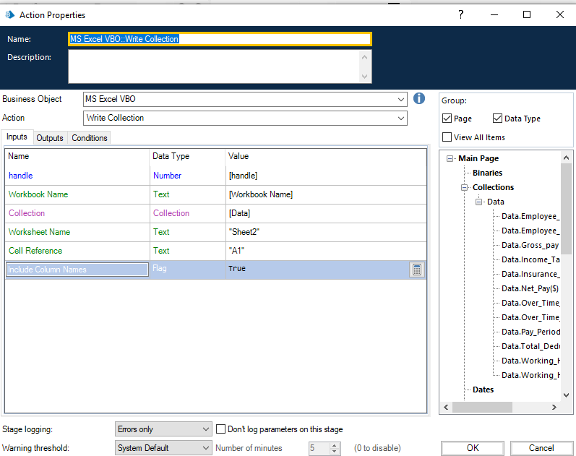

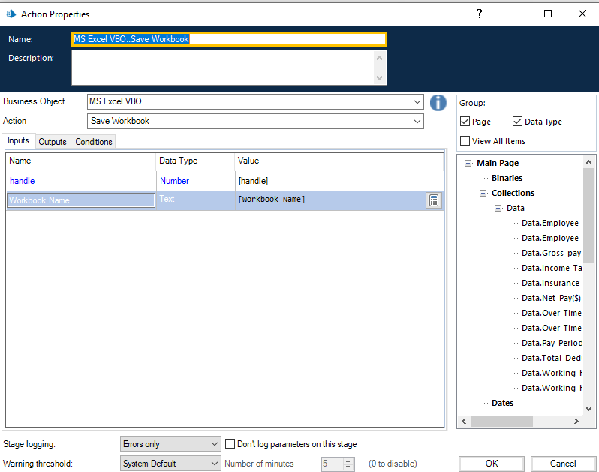

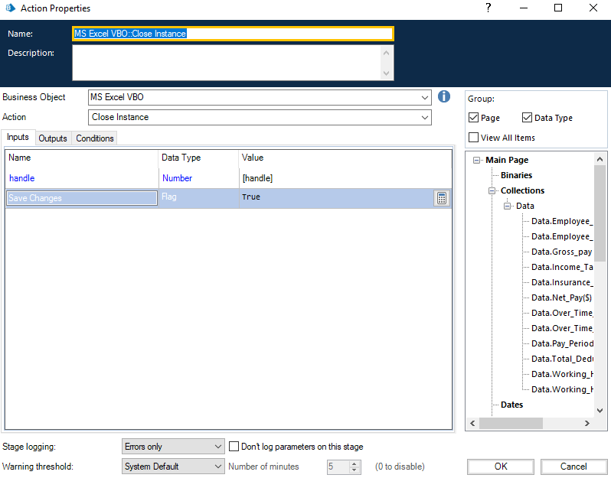

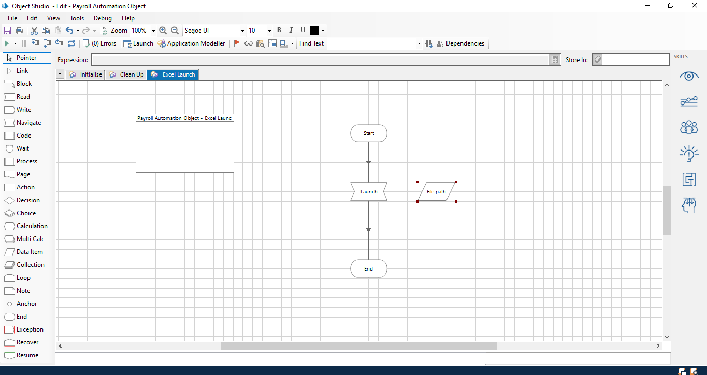

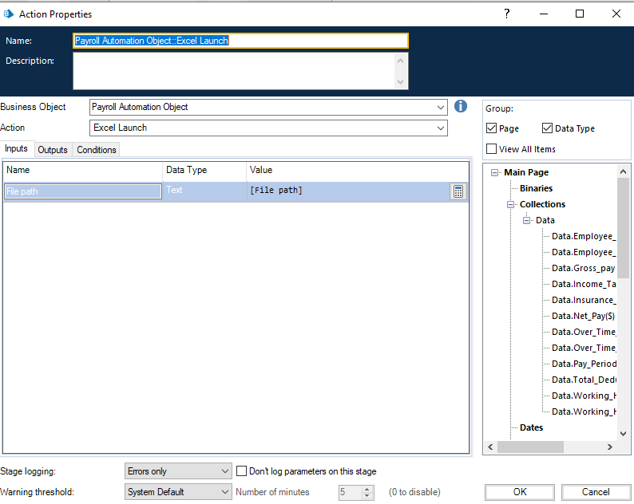

**Input:**

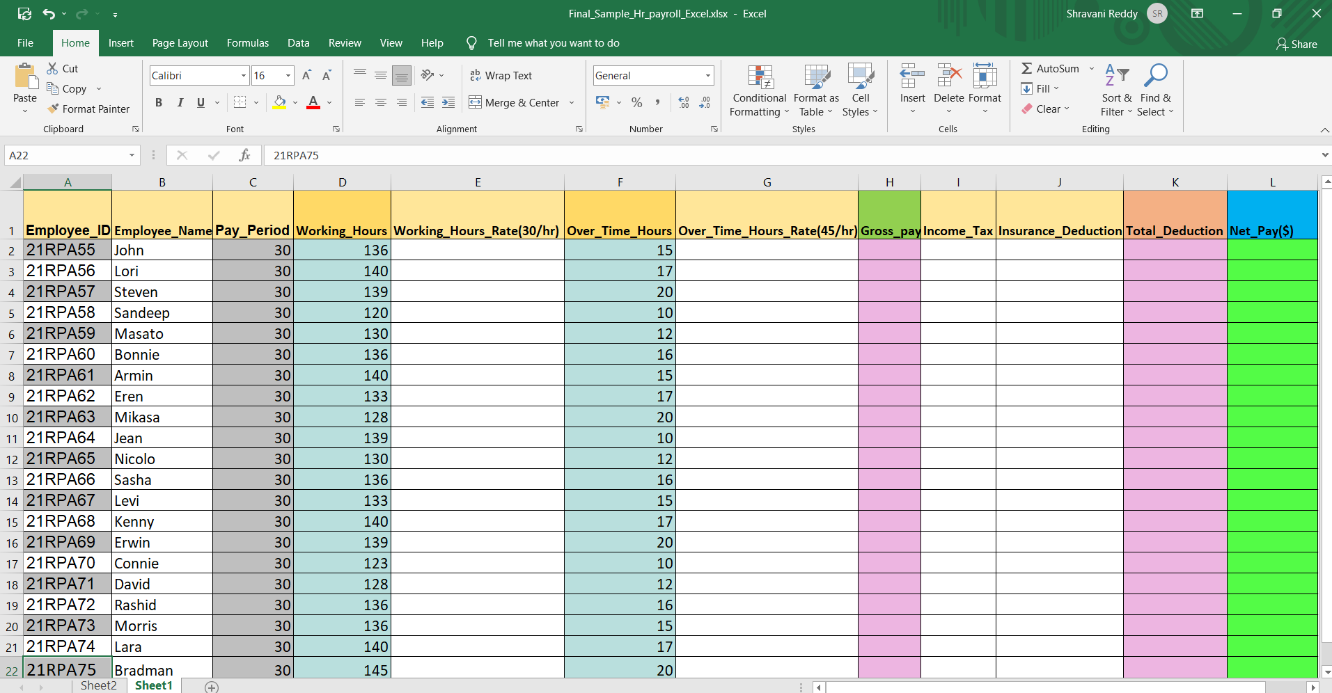

**Output:**

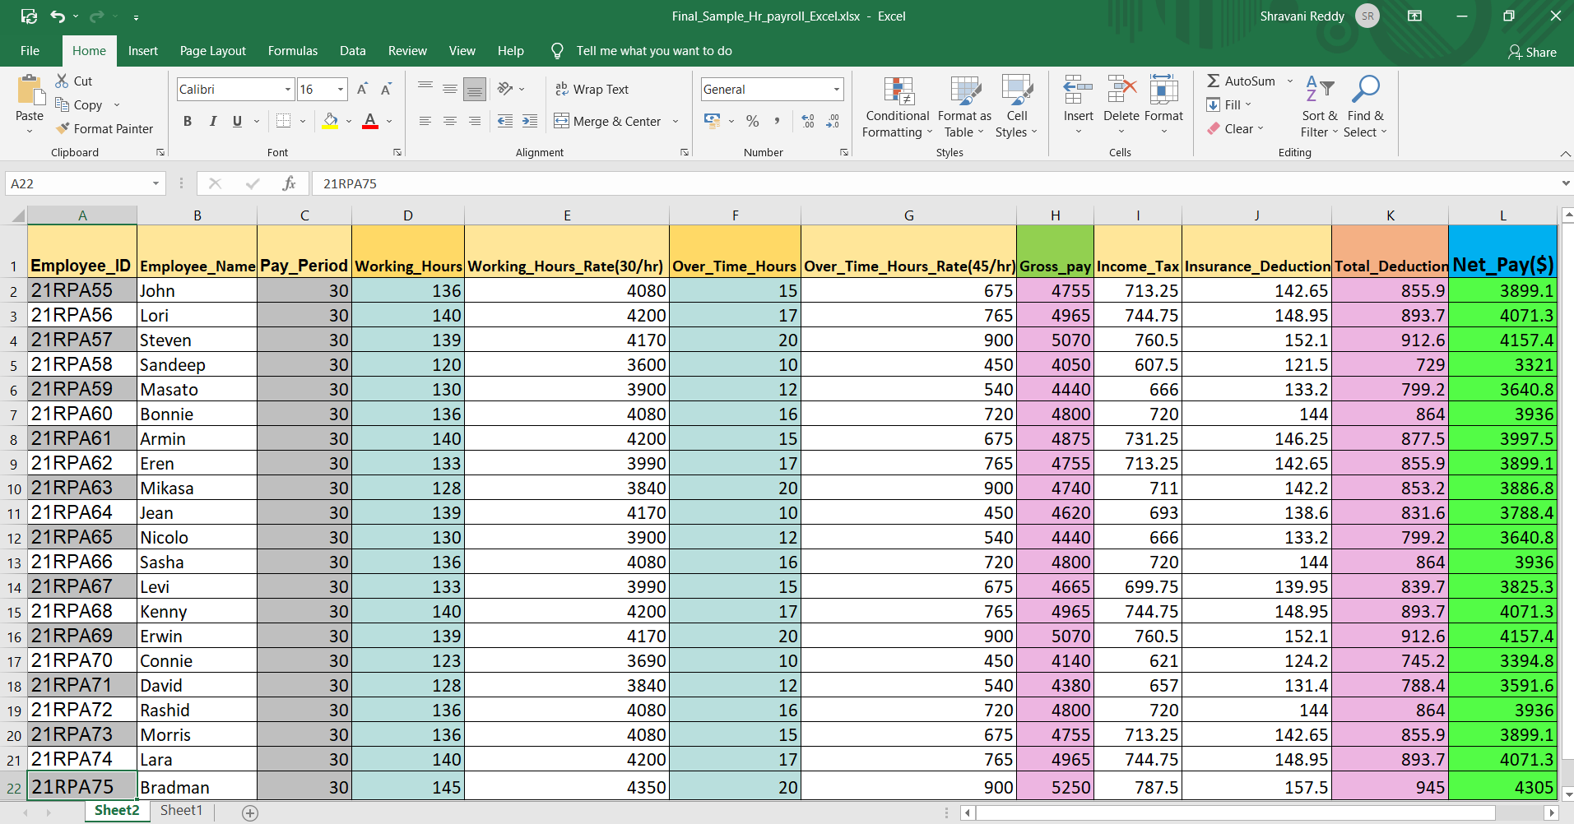

**Pros:**

* Work is done efficiently.
* Instead of spending hours together on calculation, the work can be accomplished within few seconds.
* Work is restricted just to data entry.
* Results are precise.
* Calculate bonuses, expenses, holiday pay, etc with minimum effort.
* Easy alteration of flow according to the data.
* Reduce the burden of compliance.
* Automate certain tasks, such as year-end reporting.

**Cons:**

* File path should not consist of any spaces.
* Generally more expensive compared to manual payroll systems.
* Needs standard computer setup in order to operate it well with certain prerequisites.
* Chances of data loss or theft.
* The repetitive task can be tedious sometimes.
* Does not easily understand which processes can be automated easily.
* Does not give HR more time to spend on tasks that enhance performance.

**Applications:**

Here is a list of six features every HR automation software must have:

**1. Actionable Insights**

Speed up the decision-making process with visual-rich reports and dashboards.

**2. Omni-Channel Access**

Access information related to any HR process, anywhere, at any time, on any device.

**3. Quick Integration**

Synchronize data with other HR management systems through API integrations.

**4. Risk Mitigation**

Make all HR processes tamper-proof with audit trails and 360-degree visibility.

**5. Automated Alerts**

Set automated alerts to keep employees on track and complete tasks on time.

**6. Dynamic Workflow**

Design unique, automated HR workflows that are in tune with every HR process.

**Conclusion:**

Human resource management is an essential part of every company. Whether it’s hiring new employees, training, or ensuring that local labor laws are complied with, HR processes are a vital part of every company.

But HR has usually been thought of as a highly manual department process. They are used to rolling up their sleeves and getting the job done themselves. But all that’s changing.

Automation is invading the HR space, and very soon everything that can be automated, will be automated. Current HR staff need to adapt to the coming changes or will be left behind.

HR automation is the process of enhancing the efficiency of the HR department by freeing employees from tedious manual tasks, and allowing them to focus on complex tasks like decision making and strategizing. By automating standard and repetitive HR activities, organizations can reduce the cost and time they spend on manual HR planning and processing.

HR automation influences people, organizations, and societies in innumerable other ways. Perhaps we can identify some unique effects that Information Technology has on the way we live, learn, work, and play. The changes caused by HR automation introduce a variety of new issues for individuals and Organizations and radically alter the importance of certain pre-existing cultures and practices.

Despite having number of limitations, this automation serves its purpose wholesomely. The HR Payroll Automation is an emerging trend in its field and is widely used by companies to reduce the workload of their employees.

Employees believe that HR automation will help in increase of access of information within the organization. This will further enhance the clarity of work as adequate and necessary information dissipation. They agree that there is a timely availability of information to carry on the work process due to automation. Individuals agree that HR automation has helped in the timely credit of their salary or income and hence made the whole system of salary administration simple.

Automating HR processes encourages better and virtual feedback. They believe, automating HR processes will help in building the concept of egalitarianism. A sense of togetherness within the organization. This will improve relations and further enhance the organizational culture. People also perceive that HR process automation will make people more virtual. The major findings also include the fact that employees believe Automating HR processes will not delay the decision-making time.

This Payroll system is accessible on the internet and calculates, maintains and records the payroll information of employees. This application helps the admin, Hr. and management of the organization to easily check the salary of the employee according to their working hours.

This Application will help to automate payroll system of an organization.

**Future Scope:**

For HR, automation increasingly affects workforce strategy. It vastly expands the potential of, and expectations for, HR analytics. Technology is transforming traditional HR functions such as hiring, training and benefits administration. And the execution of all this change demands a strong HR role.

The understanding and use of the power of automation may prove to be the dividing line between those who advance in the field and those who are marginalized and, eventually, automated out of their HR jobs.

Automation drives advancement not by eliminating jobs but by eliminating particular job functions at which humans are inefficient, inconsistent or exposed to risk.

As a practical matter, experts expect that automation will lead to a declining number of generalist employees responsible for mundane repetitive transactional tasks, including HR generalists. At the same time, more HR staff will be performing analytical functions and getting more involved with other organizational activities.